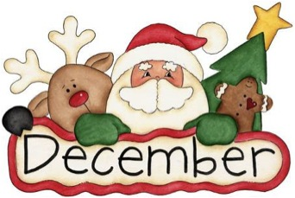
Star Light Early Learning Center

 |  | 1 | 2 | 3 | 4 | 5
6  Happy Birthday,  Ms Amber! | 7  Board Mtg  6:30pm | 8  Book Orders Due | 9 | 10 | 11 | 12
13 | 14 | 15 | 16  Happy Birthday, Liza! | 17 | 18  Paper Work Due | 19
20 | 21 | 22  Christmas Party  8:30-11:30 | 23 | 24  Close at 3pm  Christmas Eve | 25  Closed  Merry Christmas! | 26
27 | 28 | 29 | 30 | 31  New Year’s Eve | 1  Closed  New Year’s Day | 2

