August News - 2020
Fundraisers: The collection of Hy-Vee receipts will resume in the fall. Thank you to those who brought any in.

We are now accepting donations to offset cost of our Toddler Room and Playground. Any amount is appreciated. Thank you!

Upcoming Events:
August 3: ELC Board Meeting
August 25-Sept 3: Introductory Conferences
September 4: Last Day of Summer Care
September 7: Closed for Labor Day
September 8-9: Closed for Staff Work Days
September 10: School Year Begins for 20-21

Star Light ELC Board Meeting: If any parents would like to come to the board meetings, you are welcome. Meetings are once a month and usually last an hour and a half. Our next meeting is August 3 at 6:30pm.
Playing Outside
Please make sure your child has appropriate attire to be outside. We try to go out daily. This summer we will be doing water play. Please be sure to have a bathing suit and towel in their backpack. We may do this any day!

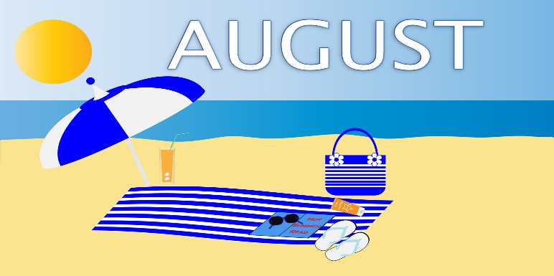
Curriculum Themes this Summer:
We are finishing up our Ocean theme and Ms Kathy is incorporating some of the Fruits of the Spirit into our last week. We will finish our summer with an Author Study on Eric Carle and his books such as Brown Bear, Brown Bear and The Very Hungry Caterpillar.

WE ARE EXPANDING!!!
We are now accepting registrations for both our Preschool and Toddler Rooms for September of 2020. Tell your family, friends and neighbors! Call Amber to schedule a tour. 257-3502
Looking Ahead…
We will hold introductory conferences during the weeks of August 25 and September 1. Conferences will be held with the lead teacher of the classroom and ONE parent, using social distancing and cloth face coverings. More details will be sent home.

Summer Care ends on Friday, September 4th.

We will be closed on Monday, September 7th for Labor Day. We will be closed to students on Tuesday and Wednesday, September 8th and 9th, for staff work and training days. Our school year begins for 2020-2021 on Thursday, September 10th.

