December News
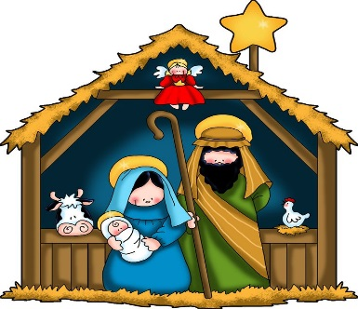
2020

Fundraisers: Our ongoing fundraisers include collecting Hy-Vee receipts. You can bring them in any time and drop them off in the brown Hy-Vee box on the cubbies
Upcoming Events:
December 7 6:30pm
Board Meeting
December 8 Book Orders Due
December 22 Class Christmas Party
December 24 Close at 3:00pm
December 25, January 1 Closed

Amber’s Angle:
November was a month to be thankful. I am thankful for all of our students here at Star Light Early Learning Center. God’s blessings to each and every one of us, and the mercies that He shows us every day. In what ways have you been thankful this past month?

Playing Outside
Please make sure your child has appropriate attire to be outside. We will try to go outside to play during the winter months if the weather cooperates.

Themes this Month:
Christmas and New Year’s
Letter: J K L Number: 10, Review 1-9
Shape: Star Color: White

This month, we will be doing a special online project for you to view, make some crafts, decorate our tree and have our Party on Tuesday, December 22. (Details on the back.)

Chapel Time with Pastor Myers:
We have had a fun time learning about some inspiring people from the Bible. We have read about Joseph and his brothers, and his dreams. We have read about Moses and how he lead the people out of Egypt. We will be reading the stories that lead up to Christmas and the people that told us about that night so long ago. Lord, Thank you for your stories passed down by the generations. May you bless us this holiday season and look out for those that may not be as fortunate as all of us. Amen.

Looking Ahead…
Our Christmas Program has been cancelled due to COVID. The children of Star Light will be producing a special online project for you to view on Facebook. So like our page and watch for this special event!

On Tuesday, December 22, we will have our class Christmas Party from 8:30-11:30am. Each student will draw the name of another student and we ask that no more than $10 be spent on a gift for that student. A separate letter will go out with the drawn names. It is also pajama day! Children (and parent volunteers) can wear their pajamas to school for a comfy Christmas! And yes, Parents can come celebrate with us! We are looking for some helpers during our Party. We will decorate cookies, play Christmas Bingo, read the Christmas Story, watch a movie and open gifts.

We will be closing at 3:00pm on December 24th and closed on 25th. During the holiday weeks, we like to know ahead of time if your child will be absent. Please let us know if your child will be home with you during these two weeks. Classes will resume on Monday, January 4th.

Star Light ELC and Epiphany Lutheran Church Mission Project:
Undies Under the Tree
We will be collecting new items of underwear, socks and bras for children and adults of all ages. Please bring in your donations and place them in our box under the tree in the hallway. They will then be distibuted to the REACH Center, Salvation Army and other places that can give them to people in need. Thank you for your gift!
Other giving this holiday season: Follow the reverse Advent Calendar to collect items for the tree and our Epiphany Little Pantry. Bring donations on January 4th when classes resume (or before if you shop early). Again, thank you for your generosity this holiday season!

